**Plan**

1. General idea of the topic
2. Multivariate Gaussian distribution
   1. Gaussian distribution
   2. Multivariate Gaussian distribution
3. Gaussian processes
   1. Matlab example
   2. Example with conditions
4. Understand the code
   1. List of tools used in the code
   2. Learn Python
   3. Try to rewrite the code in Python

**General idea**

Input data: video data (high-dimensional time series)

Output data: generated video data

**Steps:**

1. **Dimensionality reduction**

Dimensionality: N x M x F, where

N x M – resolution of a video, F – number of frames

For instance: 300x200 with 250 frames (25 frames per second)

***Apply reduction algorithm, choose top 20 features***

As an algorithm it can be linear (like PCA) or nonlinear

Linear algorithms cannot capture complex dynamic textures

Some nonlinear algorithms produce irreversible mapping

Some nonlinear algorithms produce different coordinate systems

**Find an algorithm which is free of these weak points**

* Infer reduction function using Gaussian Process

1. **Dynamical texture modeling**

Learn dynamic texture

It cannot be linear, most of dynamic textures are not linear

It can be switching or piecewise linear, but not for all dynamic textures

**Find a more flexible model**

* Dynamic texture can be modeled using first-order Markov model based on Gaussian Process

1. **Dynamical texture synthesis**

Generate new video data using learned dynamic texture

Estimate necessary parameters (latent variable vector, observed dynamic texture vector, kernel matrix mapping hyperparameter, weights for kernel functions and different kernel parameters), then predict new sequence of dynamic textures

It is necessary to have a good performance at this step

**Adopt mean-prediction method**

* Based on first-order Markov model using Gaussian prediction

**Gaussian distribution**

Gaussian (normal) distribution – continuous probability distribution, bell shaped and symmetric. Characterized by mean and standard deviation. Total area under the distribution curve equals to 1.

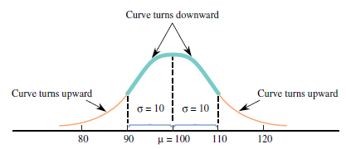

Mean – describes where corresponding curve is centered.

Standard deviation – describes how much the curve spreads out around center.

Joint distribution of two dependent/independent events

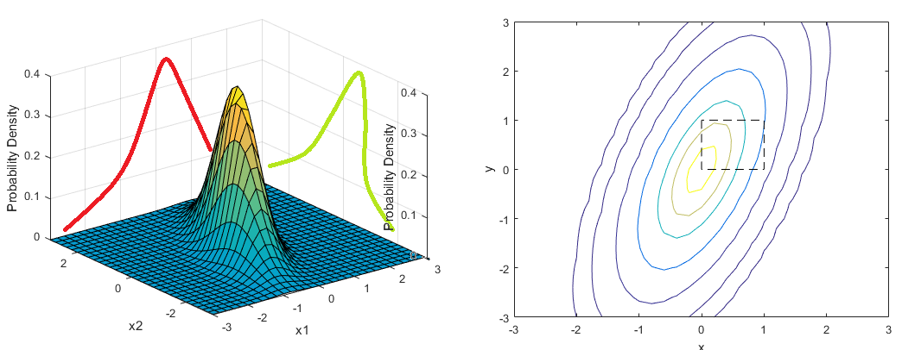

**Multivariate Gaussian distribution**

Bivariate case – for any fixed X1 value the distribution of associated X2 values is normal and for any fixed X2 value the distribution of X1 value is normal.

Multivariate case (2 or more dimensions) – characterized by:

1. Mean vector – the same size as data
2. Covariance matrix – squared matrix DxD, where D – dimensionality (in bivariate case 2x2)
3. Shape of a cut (2D projection) – diagonal elements of covariance matrix are equal, sizes of directions are the same – contour is spherical

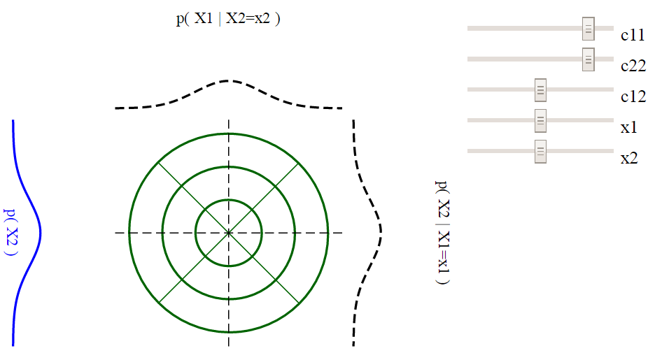

otherwise contour is shaped

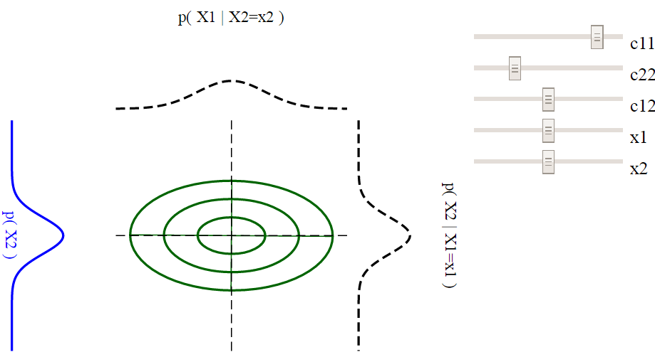

also, it can be rotated as well

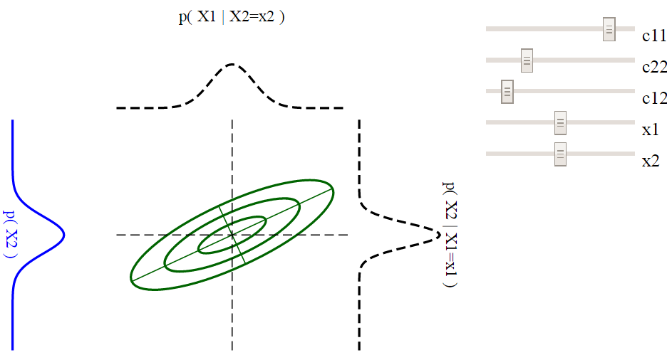

size and orientation of ellipse can be understood by looking at eigenvalues and eigenvectors of covariance matrix.

Eigenvectors shows directions, eigenvalues – scale.

**Matlab example**

Kernel matrix

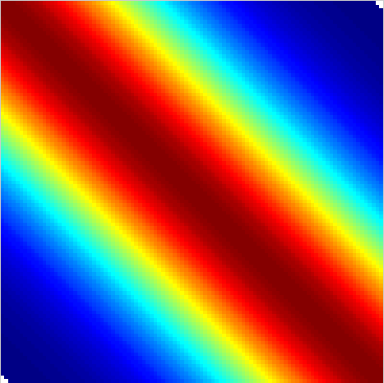

10 possible realisations with respect to this kernel matrix

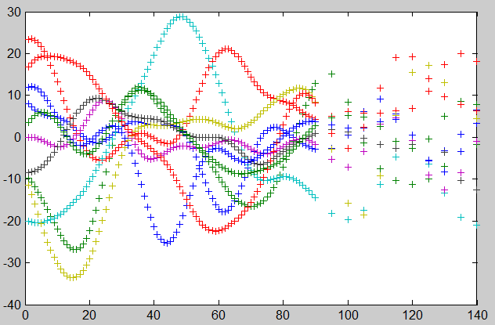

**Example of conditional distribution (with known parameters)**

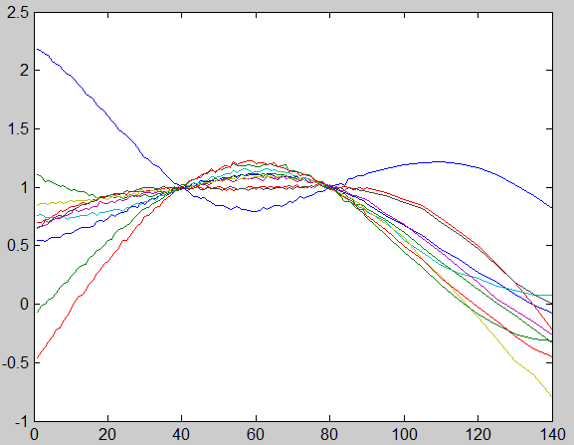

**List of tools used in the code**

*Preprocessing:*

1. Open a video file

2. Extract frames (images)

3. Resize frames (images)

*Processing:*

1. Convert image to grayscale

2. PCA

3. Matrix multiplacation

4. Kernels: linear, RBF (Radial Basis Function), Polynomial, RATQUAD, MLP (Multilayer Perceptron), Matern32

5. Creation of a kernel

6. Function initKernWeight for combined kernels defenition

7. Function weightsConstrain for hyperparameters initialization

8. Function kernExpandParam for combined kernel structure definition

9. Function updateKernWeight

10. Hyperparameters optimization function gpdm

11. Prediction and sample reconstruction

12. floor, ceil

13. reshape an array into the matrix

14. Save data back to video file

**Second meeting:** What have done in last 2 weeks?

1. Git
2. Course on Software carpentry
3. Jupyter Notebook
4. Reimplementation in Python

* Univariate Gaussian and joint distribution
* Multivariate Gaussian (library function, own function, conditional case, noisy kernel)

1. Model review in MD and Latex
2. OpenCV and preprocessing stage

**Questions:**

1. Can we use different kernel functions in conditional case?

In our setting – no.

1. How to rewrite in matrix form?

Just do it. Python uses broadcasting. However, be careful.

1. What is the best way to use matrices in Python?

Arrays. However, there is another class called *matrix* in numpy, sometimes it is more convenient to use arrays. I should be careful with using different classes at the same time.

1. Why do they use PCA?

They use it for initialization. Read the Algorithm in the paper.

**Following plan**

How to estimate missing frame?

* How to represent missing frame in original set Y? - go inside PCA and think (defend something).
* Theoretically, we'll find x related to missing y from PCA, but it is not a main point. We need to know Y for optimization and for prediction as well => understand mk_gpdm, mk_prediction - more important than PCA.
* I need to find SCG optimization function if I still want to reimplement the code in Python. Update the list of functions I need for Python as well.

**Next meeting:** What have done in last 2 weeks?

1. General learning algorithm understanding
2. Exact functions and gradients to be optimized and dimensionality analysis
3. Ideas of how to represent missing frames in original dataset Y
4. Little help about functions used in original code
5. Pre-processing function to make a video from rendered set of frames
6. Starting of code reimplementation using Python

Questions:

1. How to estimate one missing frame?

* Use N frames in X while use N-1 only for Y

1. How to compute Ky in matrix form?

* Reshape from N x Q to N x 1 x Q and to sum over last axis

1. Why I did't receive money?

* Check again and contact Marianne

**Next meeting:** What have done in last 3 weeks?

1. General learning algorithm understanding
2. Exact functions and gradients to be optimized and dimensionality analysis
3. How to represent and estimate missing frames
4. Starting of code reimplementation using Python
5. Gradient test module

Questions:

1. Gradient of Kronecker delta (in Ky and Kx)?
2. Gradient of Kx wrt lambda?
3. Gradient of Ky wrt theta (=Ky with theta=[1,1,1]?)
4. Problems with Poly kernel
5. Gradient of function 2 wrt W - what is the dimensionality?
6. Difference between simple GPLVM and our model?
7. Video generator module

**Last meeting:**

1. Check is there initialization of a random generator in the code

* Was not at all. Now it is.

2. Try to use all the kernels separately and compare weights and latent variables

Original sample video **straw.avi** from Dyntex database preprocessed to grayscale 120x90 pixels with 10 seconds length (250 frames):

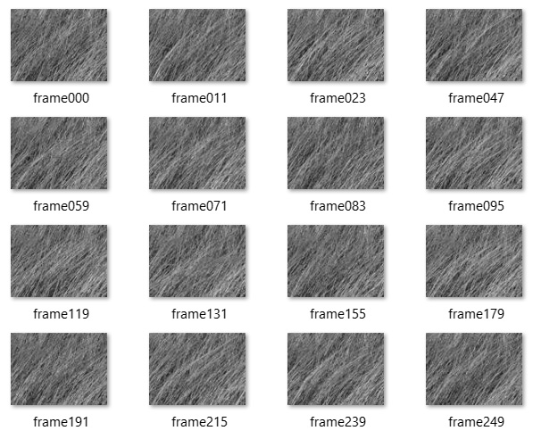

Kernels used:

1. **Linear**

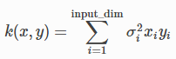

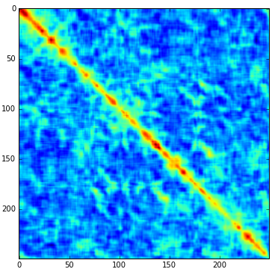

1. **RBF -** Radial Basis Function kernel

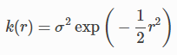

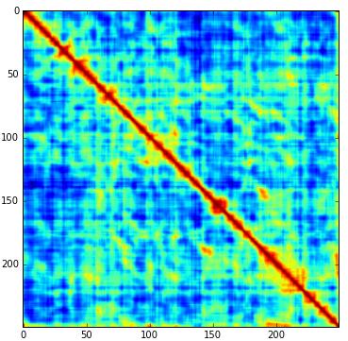

1. **Poly -** Polynomial kernel



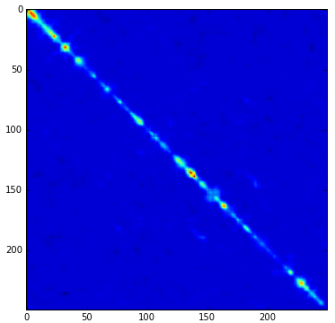

1. **RatQuad – Rational Quadratic kernel**

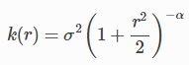

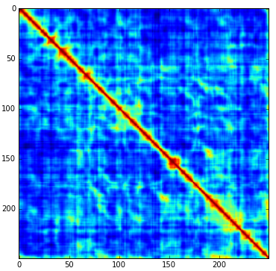

1. **MLP -** Multi layer perceptron kernel

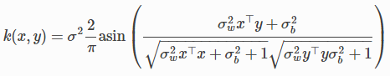

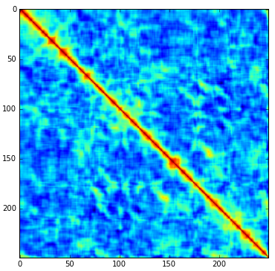

1. **Matern32** - Matern 3/2 kernel:

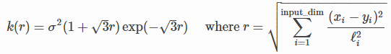

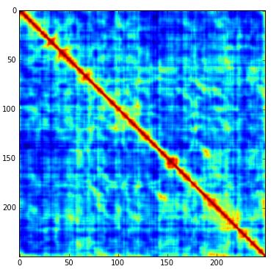

Weights obtained for kernels after optimization:

|  |  |  |  |  |  |
| --- | --- | --- | --- | --- | --- |
| **Linear** | **RBF** | **Poly** | **RatQuad** | **MLP** | **Matern32** |
| 0.040278 | 0.682626 | 0 | 0 | 0 | 0.277096 |

Kernels used separately:

1. Linear kernel

Latent variable X1 w.r.t. to time (obtained using linear kernel only – in red, using all 6 kernels – in blue):



Latent variable X10 w.r.t. to time (obtained using linear kernel only – in red, using all 6 kernels – in blue):



Latent variable X20 w.r.t. to time (obtained using linear kernel only – in red, using all 6 kernels – in blue):



1. RBF kernel

Latent variable X1 w.r.t. to time (obtained using RBF kernel only – in red, using all 6 kernels – in blue)



Latent variable X10 w.r.t. to time (obtained using RBF kernel only – in red, using all 6 kernels – in blue):



Latent variable X20 w.r.t. to time (obtained using RBF kernel only – in red, using all 6 kernels – in blue):



1. Poly kernel

Latent variable X1 w.r.t. to time (obtained using Poly kernel only – in red, using all 6 kernels – in blue):



Latent variable X10 w.r.t. to time (obtained using Poly kernel only – in red, using all 6 kernels – in blue):



Latent variable X20 w.r.t. to time (obtained using Poly kernel only – in red, using all 6 kernels – in blue):



1. RatQuad kernel

Latent variable X1 w.r.t. to time (obtained using RatQuad kernel only – in red, using all 6 kernels – in blue):



Latent variable X10 w.r.t. to time (obtained using RatQuad kernel only – in red, using all 6 kernels – in blue):



Latent variable X20 w.r.t. to time (obtained using RatQuad kernel only – in red, using all 6 kernels – in blue):



1. MLP kernel

Latent variable X1 w.r.t. to time (obtained using MLP kernel only – in red, using all 6 kernels – in blue):



Latent variable X10 w.r.t. to time (obtained using MLP kernel only – in red, using all 6 kernels – in blue):



Latent variable X20 w.r.t. to time (obtained using MLP kernel only – in red, using all 6 kernels – in blue):



1. Matern32 kernel

Latent variable X1 w.r.t. to time (obtained using Matern32 kernel only – in red, using all 6 kernels – in blue):



Latent variable X10 w.r.t. to time (obtained using Matern32 kernel only – in red, using all 6 kernels – in blue):



Latent variable X20 w.r.t. to time (obtained using Matern32 kernel only – in red, using all 6 kernels – in blue):



Visual quality of the results of using every kernel separately is contradictory to kernel weights diagram, but explains latent variable behaviour shown before. RatQuad, MLP and Matern32 kernels are able to capture dynamic texture, while other kernels cannot capture it at all and provide static textures as a result. However, comparing between them RatQuad and Matern32 provide better result than MLP.

Weights used in different videos:

Original sample video **actinia.avi** from Dyntex database preprocessed to grayscale 120x90 pixels with 10 seconds length (250 frames):

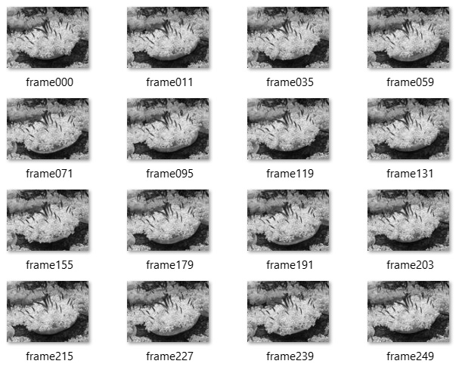

Original sample video **seawave.avi** from Dyntex database preprocessed to grayscale 120x90 pixels with 10 seconds length (250 frames):

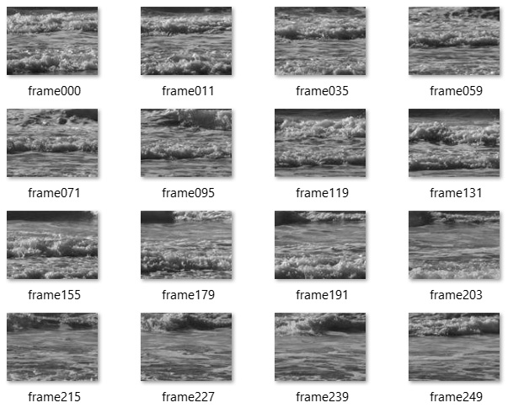

Original sample video **sunshade.avi** from Dyntex database preprocessed to grayscale 120x90 pixels with 10 seconds length (250 frames):

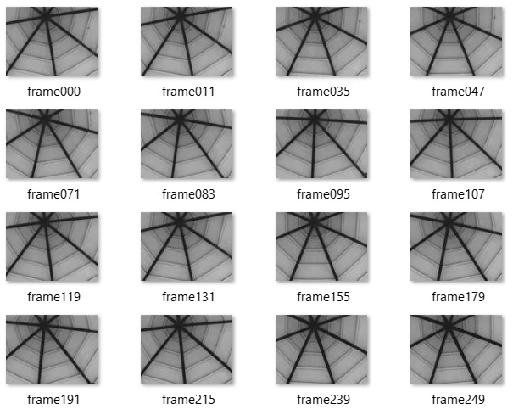

Weights comparison:

|  |  |  |  |  |  |  |
| --- | --- | --- | --- | --- | --- | --- |
| **Sample** | **Linear** | **RBF** | **Poly** | **RatQuad** | **MLP** | **Matern32** |
| straw | 0.040278 | 0.682626 | 0 | 0 | 0 | 0.277096 |
| actinia | 0.289421 | 0.312588 | 0.076728 | 0 | 0.318424 | 0.00284 |
| seawave | 0.192753 | 0.318292 | 0.092731 | 0 | 0.396224 | 0 |
| sunshade | 0.511561 | 0.003422 | 0.008163 | 0 | 0.476782 | 7.18E-05 |

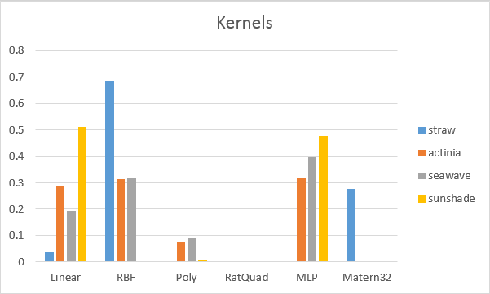

Visual quality is different for every sample and depends on dynamic texture itself. While *sunshade.avi* gives the best result, where rotation is seeing very accurately, but a little smooth, *actinia.avi* gives the worst result, where for the whole length of video actinia does not move at all. However, *seawave.avi* and *straw.avi* give quite acceptable result. Due to the fact, that the model does not use random process to generate new latent variables, the result of both of these videos has repetition of original frames sequences.

4. Missing frames estimation throw conditions (if it is not possible why?)

We cannot. Because we use conditions to bound what we want to get. If we want to get one exact frame at time t we can input it as a condition. This model doesn’t work at the opposite way.